**Business Intelligence Guidebook**

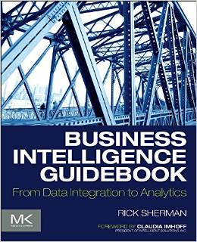

**BI Dimension Model - Detailed Design Template**



Northeastern University, Boston

BI Dimension Logical Model –

Detailed Design Template

Contoso Retail Project

Date: April 2018

Author(s): Dharit Shah

Luvesh Tekchandani

Ojas Phansekar

Raj Ravindra Phadke

Sponsor(s): Prof. Richard Sherman

Arjun Upadhyay

Labdhi Shah

Palak Agrawal

Table of Contents

BI Dimensional Logical Model Design 4

DATA STORE: [Retail_DW] 4

• Source to Target Mapping 5

• CONSTRAINTS 6

• INDEXES 7

• DATA STORE LOGICAL MODEL 8

Approvals 10

Appendix: Background Materials 11

Authors and contributors 11

# BI Dimensional Logical Model Design

## DATA STORE: [NAME]

Data Store: Contoso Retail Database

Schema Type: Relational Database Schema

Description: Retail_DW Final Project

Status: Final Submission

Last Updated: 04/28/2018

Team Responsible for Design: Team 5

**Source To Target Mappings:**

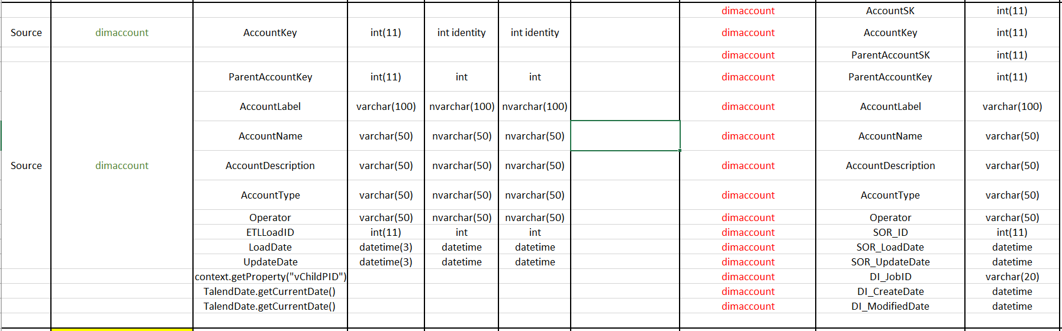

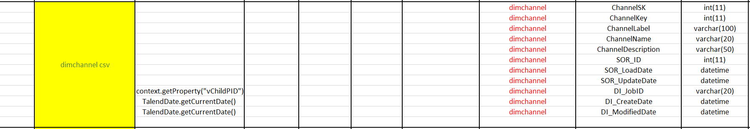

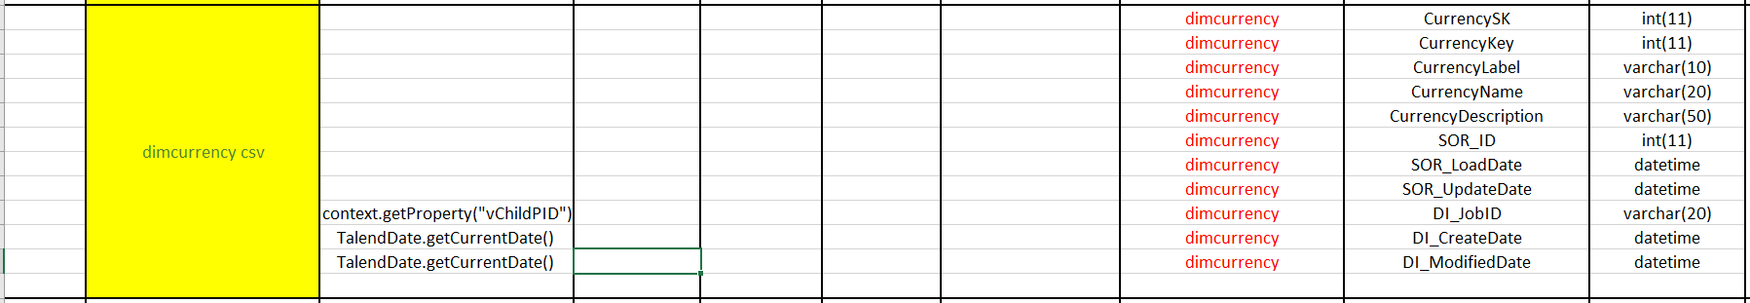

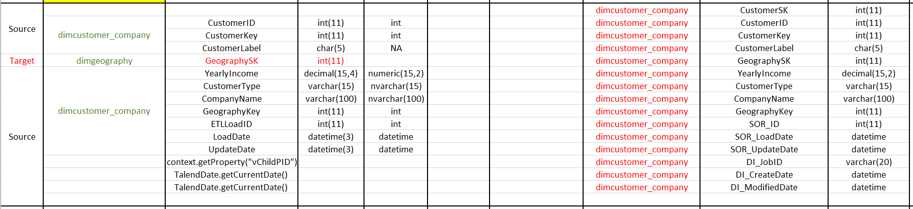

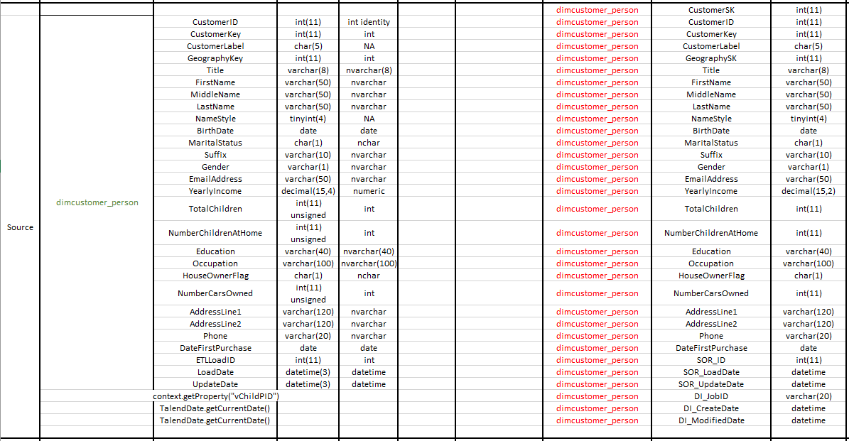

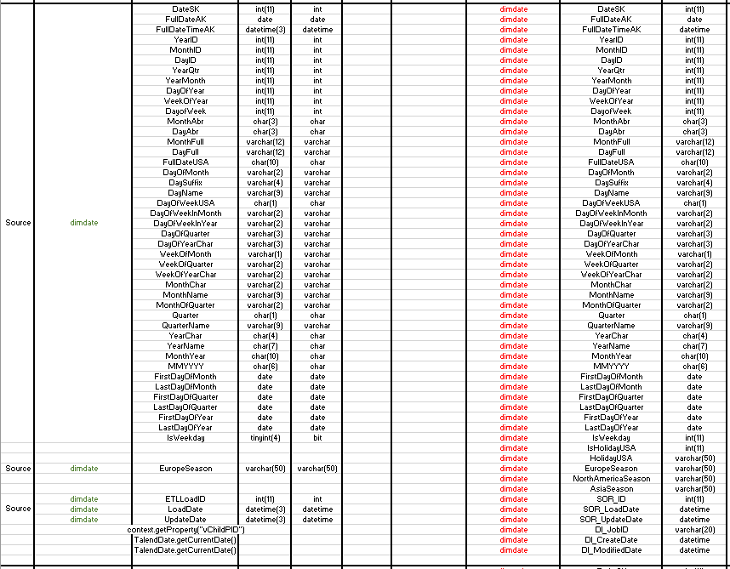

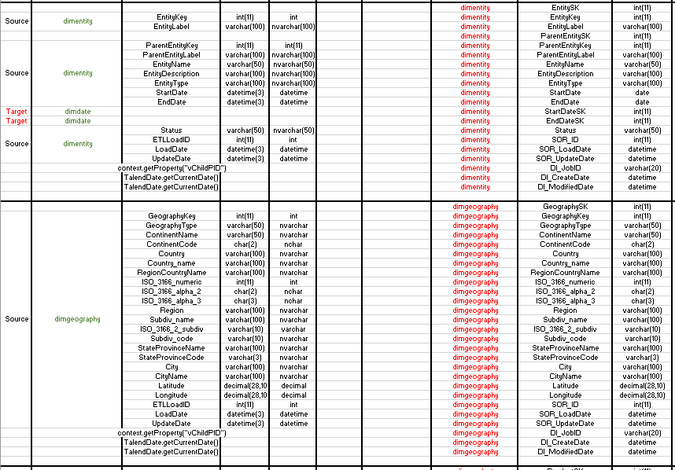

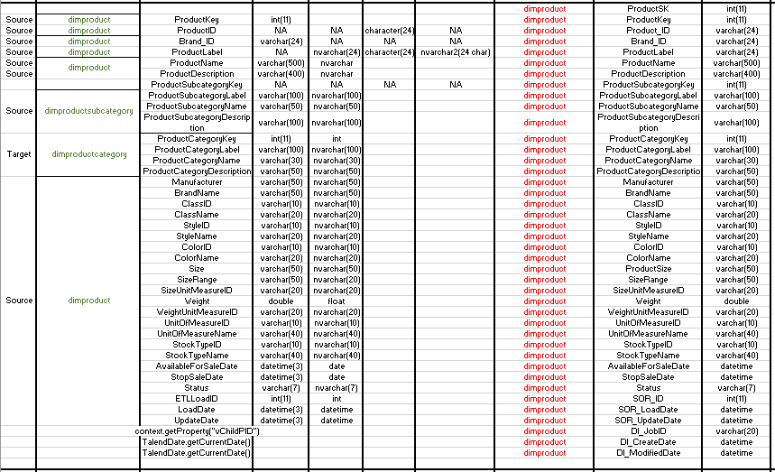

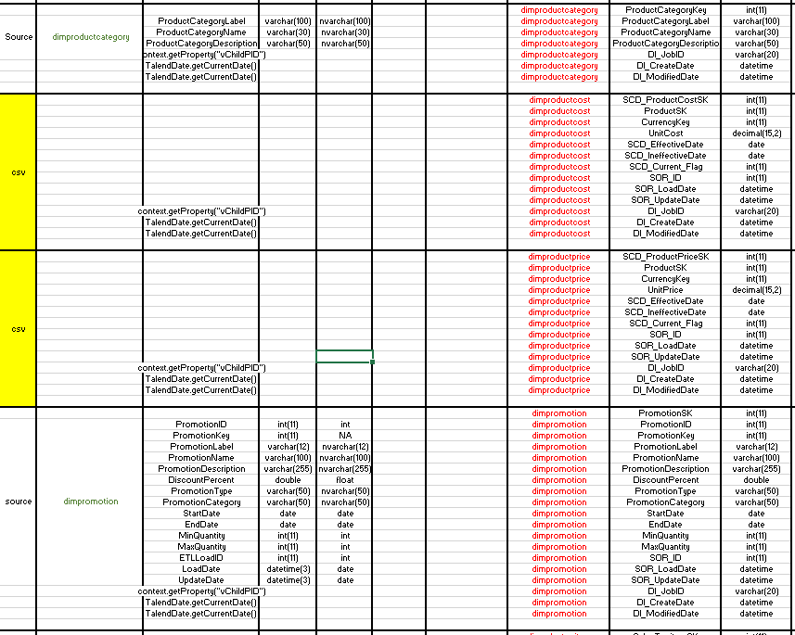

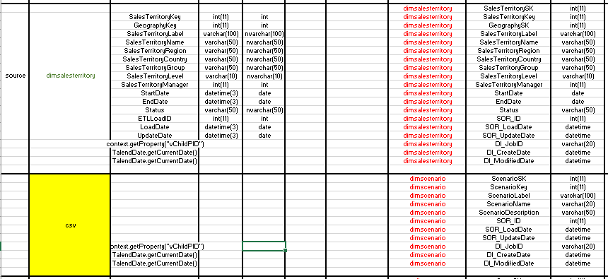

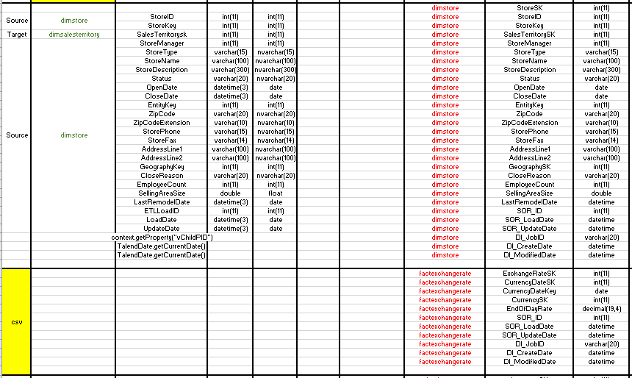

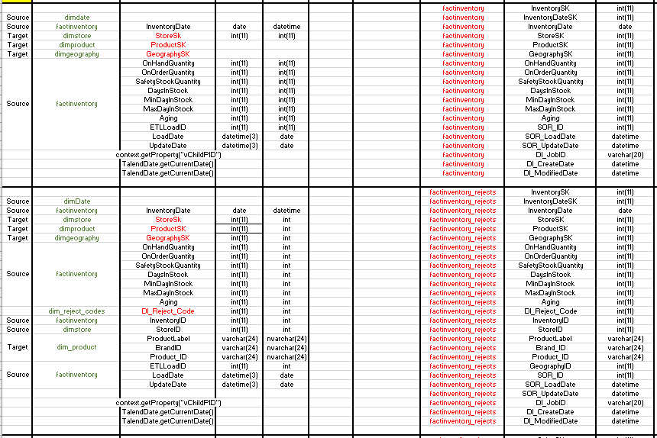

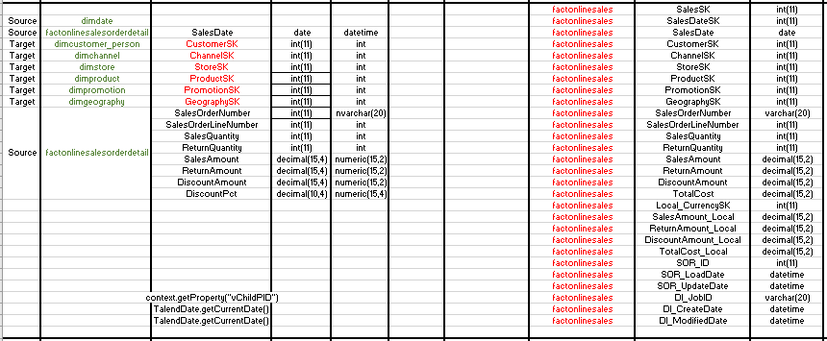

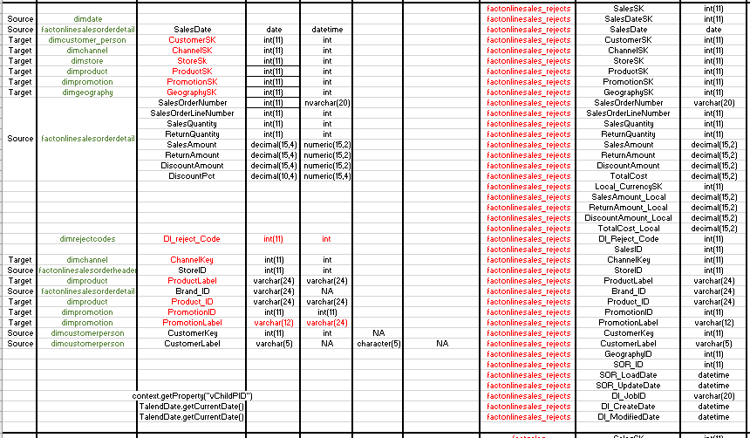

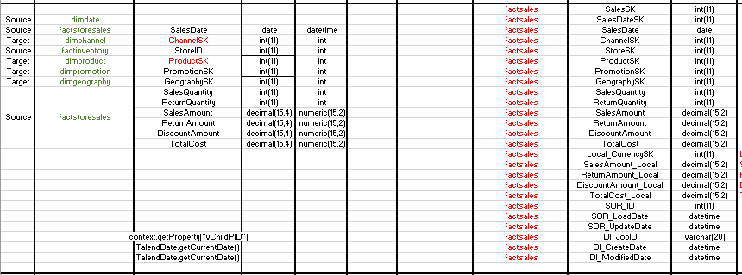

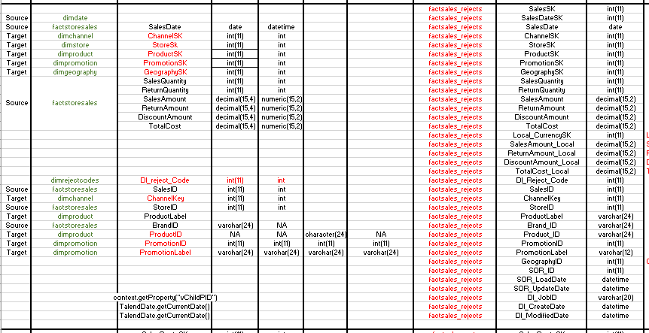

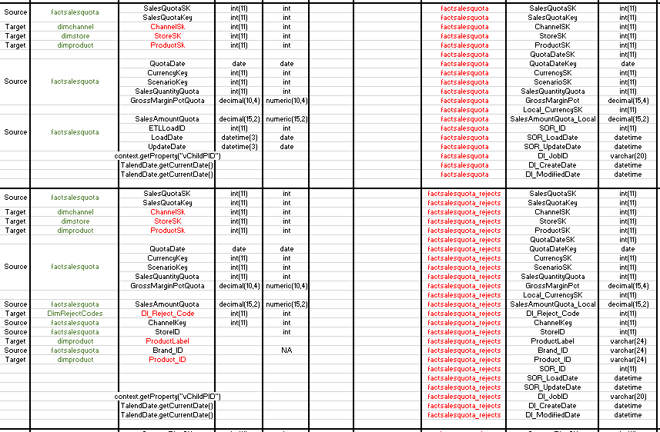

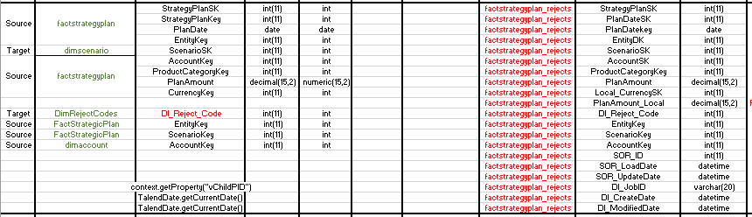

### DATA STORE LOGICAL MODEL

**Fact Inventory**

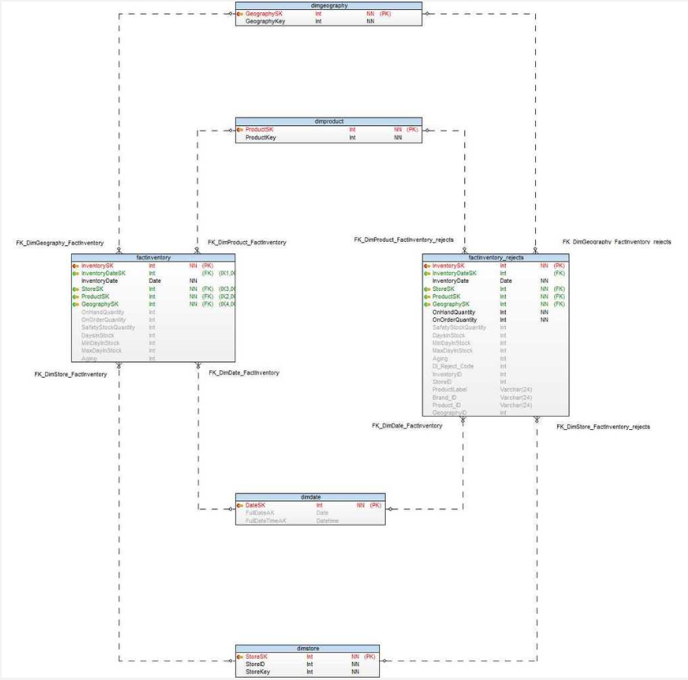

Figure 1: Example of a Data Store's Logical Data Model

**FactOnlineSales:**

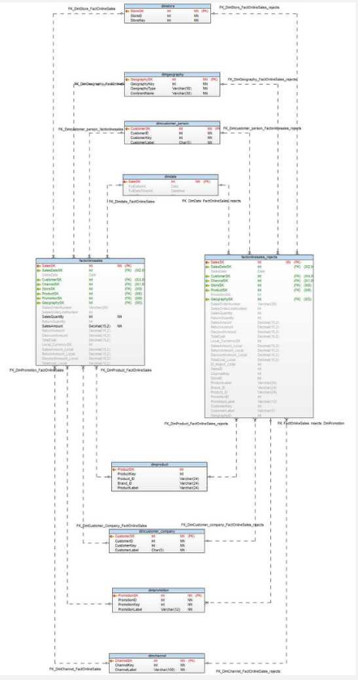

**FactSales:**

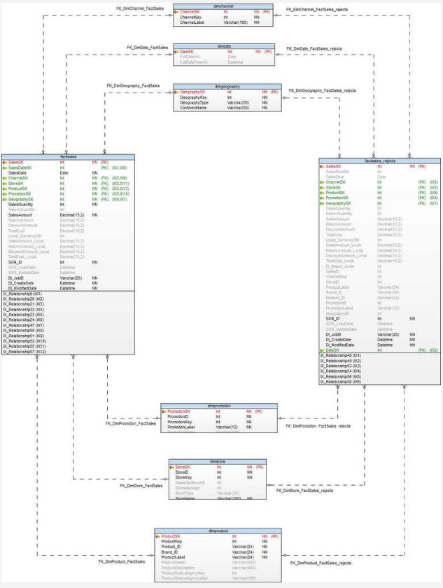

**FactSalesQuota:**

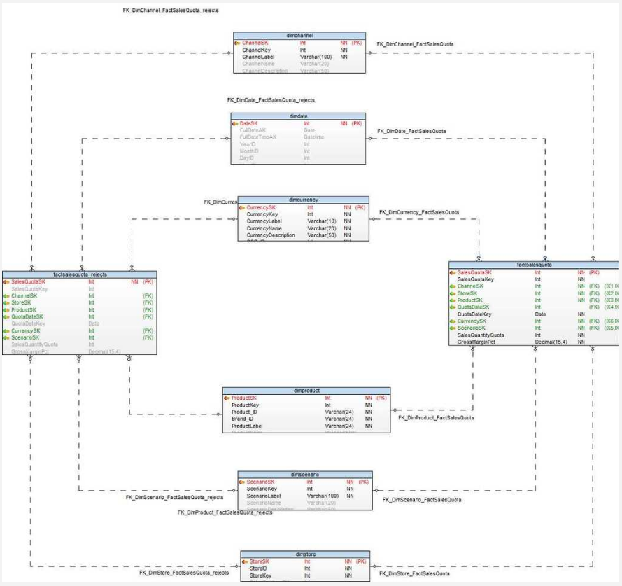

**FactStrategyPlan**

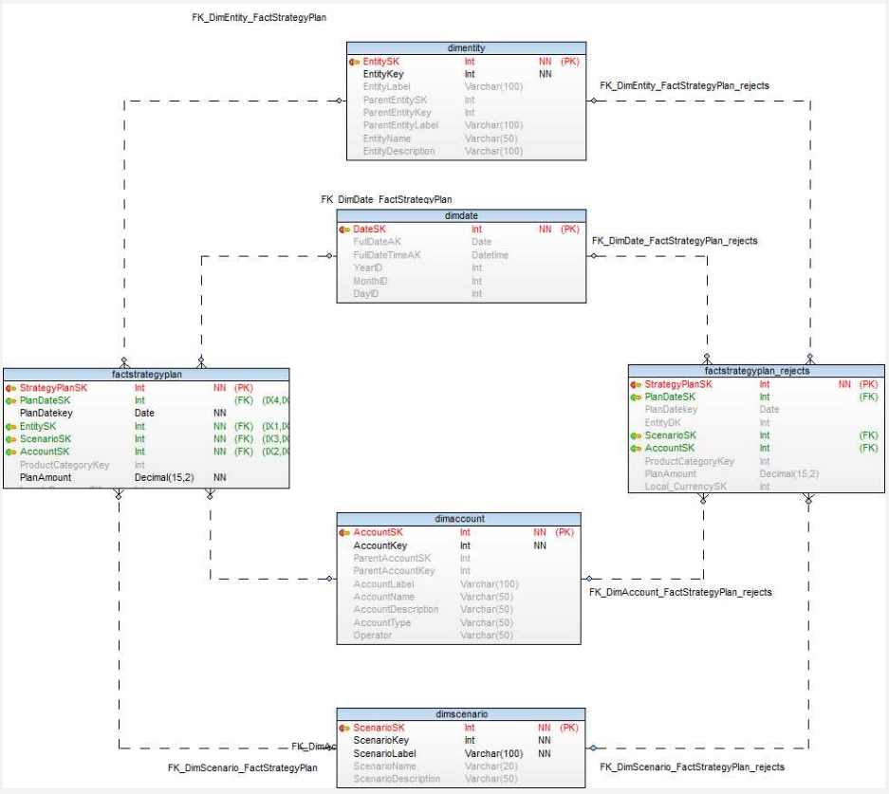

## Challenges Faced:

* To perform error handling, we first performed **Data Profiling** which included Source to Target Mappings. This is a very important and primary step in Data Integration.
* In this Contosa Retail Project we have used **Data Ingestion Services** inorder to handle effective & ineffective dates, new row for updating current records.
* **Data Ingestion Services used in our project include:**

1. Change Data Capture in the form of Audit columns
2. Slowly changing dimensions (Type 2 in DimProductCost, DimProductPrice)
3. Referential Lookups

* In order to perform String to Integer data conversion’s we used String.valueOf()
* Also to parse from BigDecimal to Int we used intValueExact()
* For implementing conformed date dimension, we used Integer.parseInt(TalendDate.getCurrentDate())
* We have used NumberSequence inorder to implement the functionality of AutoIncrement

# Appendix: Background Materials

## Authors and contributors

Dharit Shah

Luvesh Tekchandani

Ojas Phansekar

Raj Ravindra Phadke

**Authors of deliverables:**

Prof. Richard Sherman

**Special Thanks for guiding us through the project:**

Arjun Upadhyay

Labdhi Shah

Palak Agrawal